Creation of a Storage Account

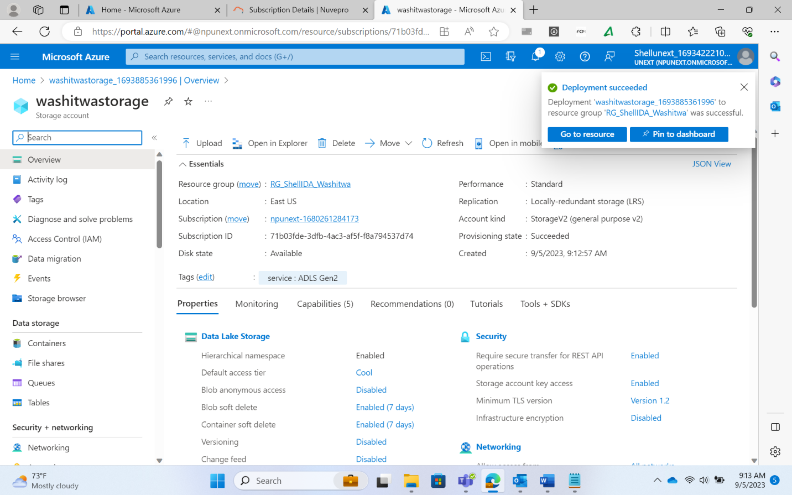

Data factory

* It is the cloud-based ETL and data integration service that allows you to create data-driven workflows for orchestrating data movement and transforming data at scale

Accessibility

* SAS: (Shared Access Signature) Time bounded. Only for a limited time
  + Read, write, delete, list, add, create, permanent delete

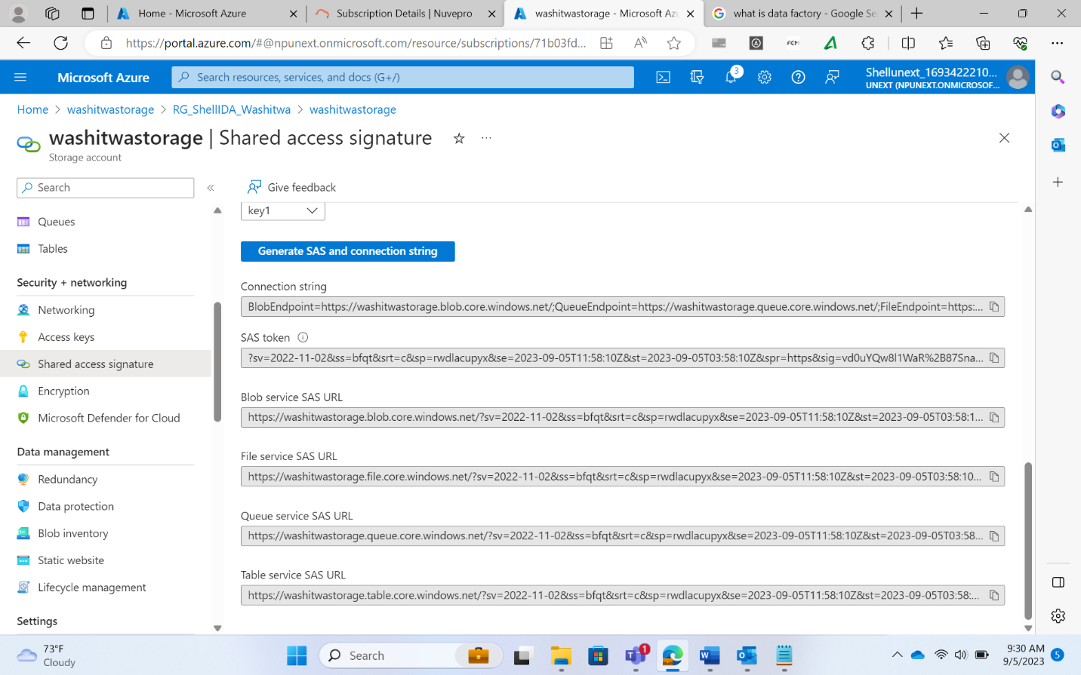

* + Upon creation of SAS, the link that is generated has to be copied immediately.
  + If the link is not copied, then a new SAS has to be created as the link is not stored in Azure.
* Access Keys: Lifelong access
  + It is for lifetime, but it is flexible i.e., we can make the accessibility time bounded.
  + A key vault is a new service that must be accessed for access keys
  + Create a Key Vault
    - Got to Marketplace Key Vault service and create a key vault
  + Azure Key Vault:
    - To store keys safely and secretly

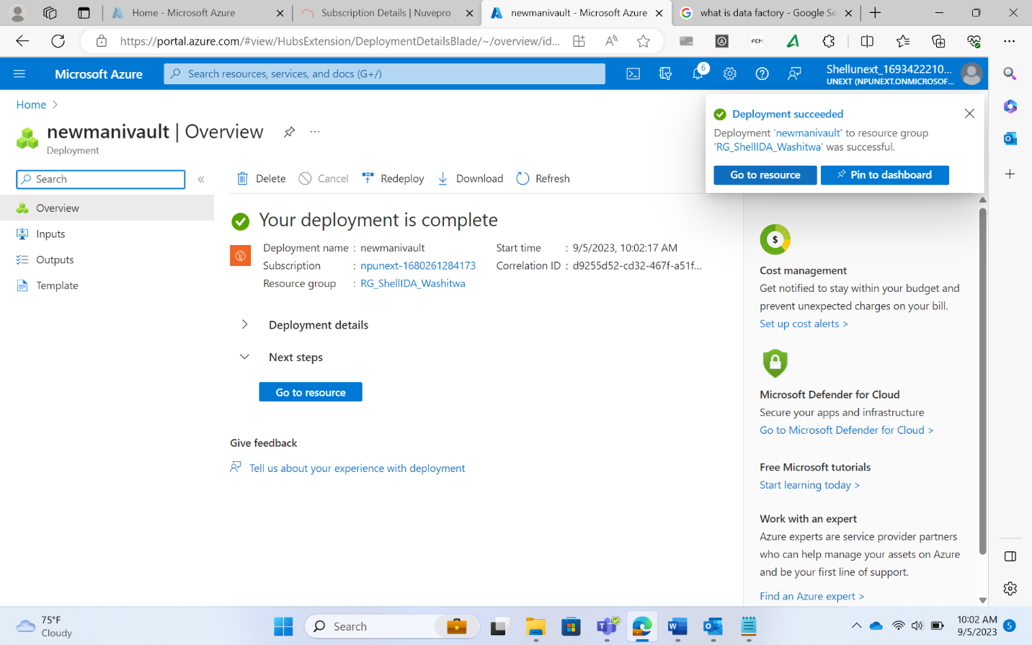

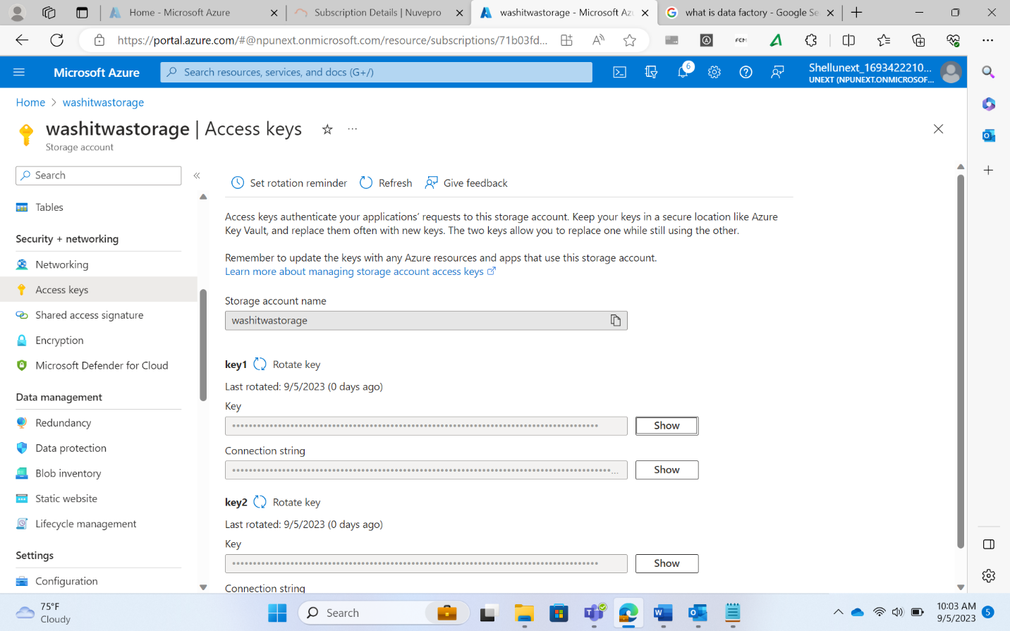

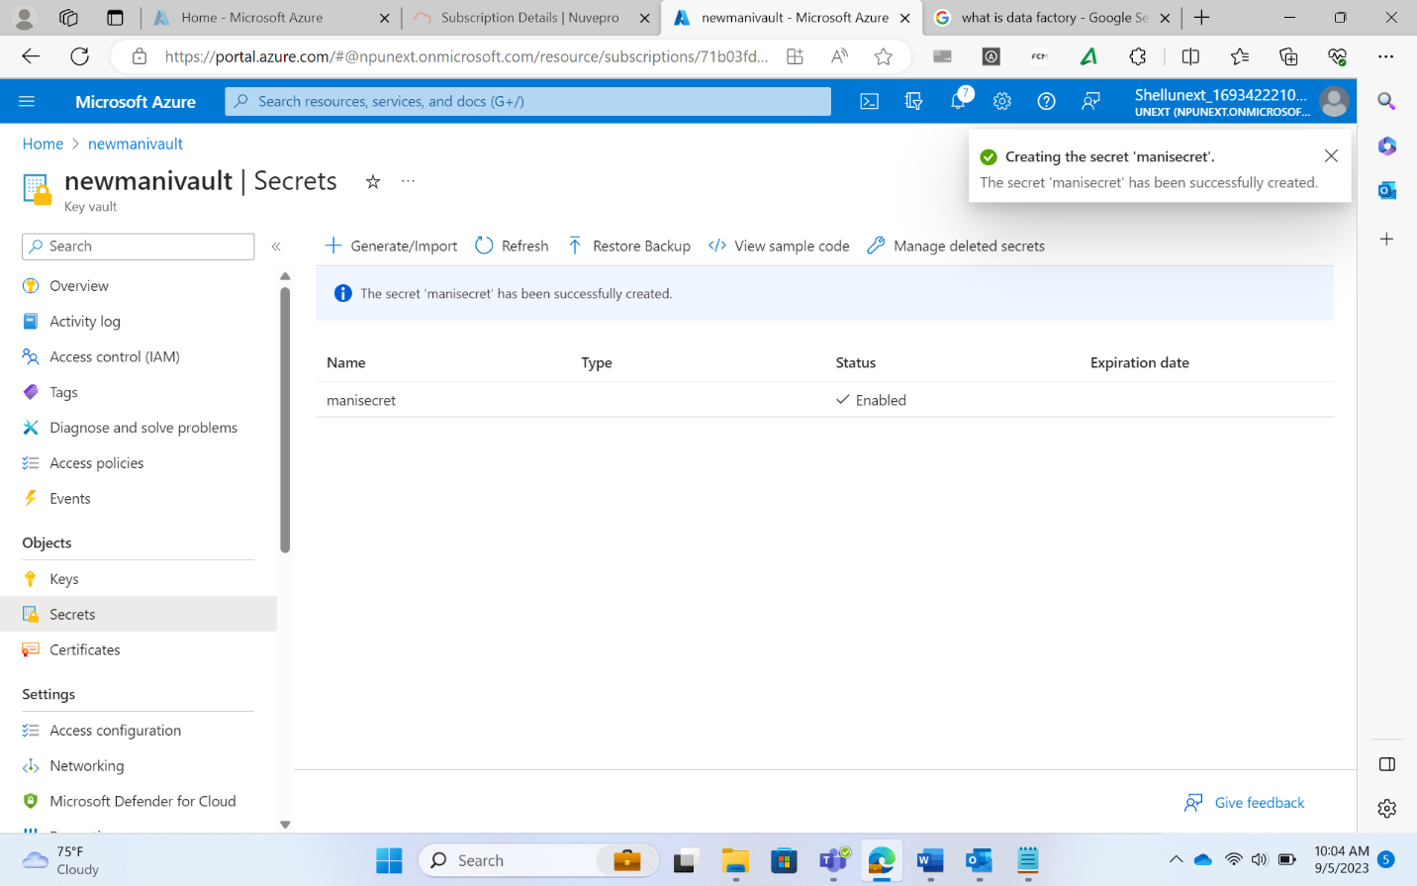

Identity and Access Management (IAM)

* Check access
* Role assignments
* Roles
* Deny assignments
* Classic administrators

ETL vs ELT

* ELT is more flexible as it allows all the data to be extracted and loaded and transformation to occur on any amount that the user prefers
* ETL only allows extraction of the data upon which the transformation is to be done

INTRODUCTION TO DATA FACTORY

ETL

* Extract, Transform, Load

ELT

* Extract, Load, Transform

ADB

* Azure Databricks
* Transformations are done using ADB

ADF

* Azure Data Factory
* Data orchestration is done using ADF
* To define the flow of data from source to destination

Pipeline creation components

* Activities
* Datasets
* Linked services
* Integration runtime
* Triggers
* Data flow
  + More than one activity makes a pipeline
  + ADF takes data from the source and sends to the destination
    - Source can be
      * Cloud
      * Local system
      * On premises infrastructure
  + ADF is a data factory that first connects to the source
  + **Integration Runtime** **(IR)** is used as a gateway to connect the ADF to the source
  + IR is different for different sources and destinations
  + **Linked Services** are used for database level access
  + **Datasets** are used for table/file level access

Work with ADF

* First find out what the source is
* Then find out and create the appropriate **IR**
* **IR** only provides access to the system
* To access the particular file, **Linked Services** are used
* Linked Services are used for database level access
* To access the table present in the database, **Datasets** are used

**IR**

* Azure Auto-Resolved Integration Runtime
* Self-Hosted Integration Runtime
* SQL Server Integration System (SSIS)
  + If an existing SSIS package is present, the package can be run on Azure

Source/Destination on cloud

* Auto resolved

Source/Destination on local system

* Self hosted

Source/Destination on cloud with existing SSIS

* SSIS

Parameterization

* Creating parameters for the name of a linked service or the dataset
* Instead of giving a hard coded name, dynamic names can be given upon every execution
* This makes them generic and reusable
* Two types of parameters

CREATION OF DATA PIPELINE

* Creation of data factory

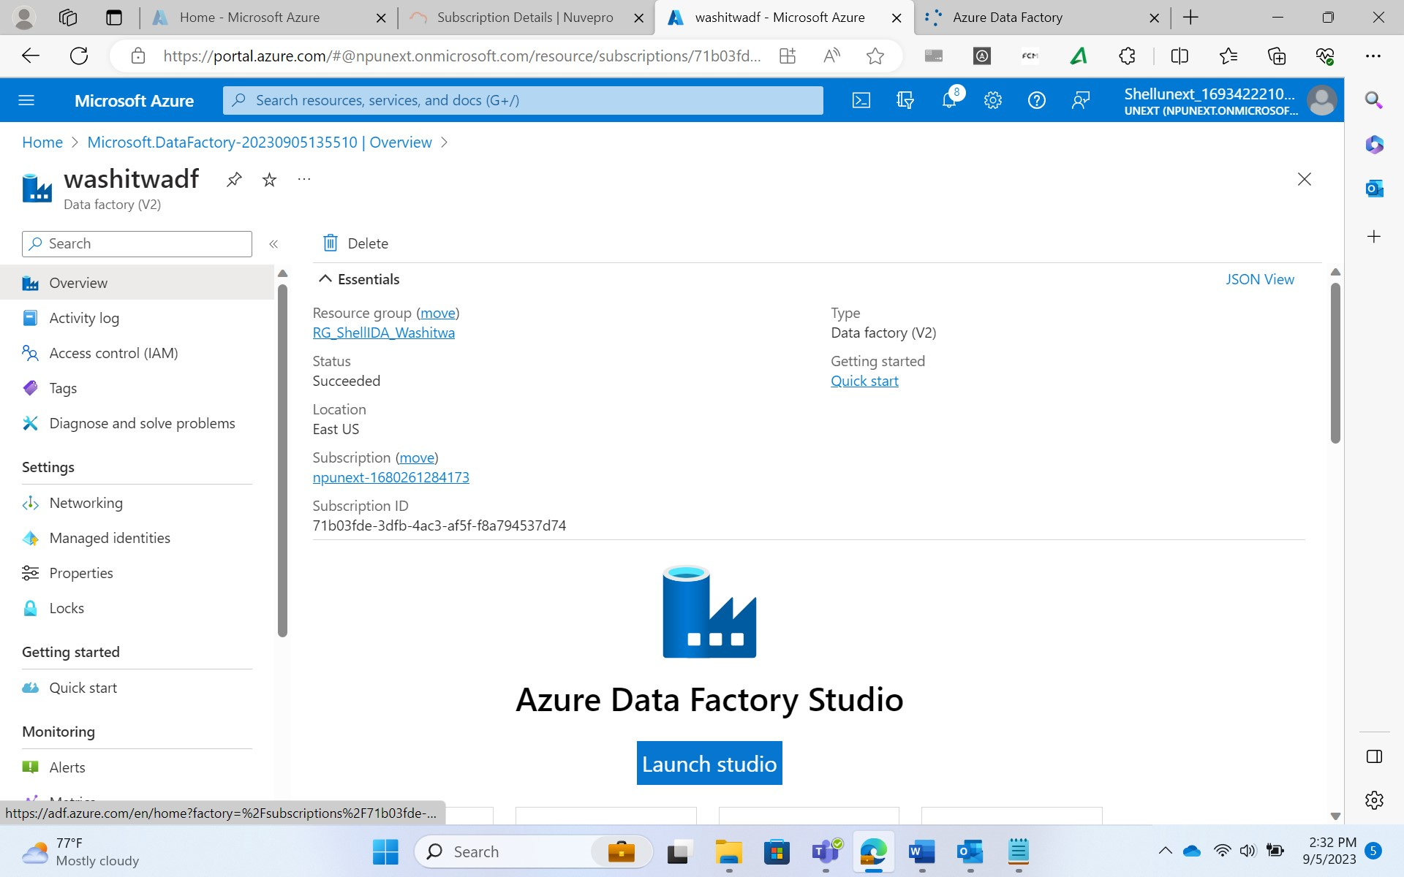

* Opening the Data Factory IDE

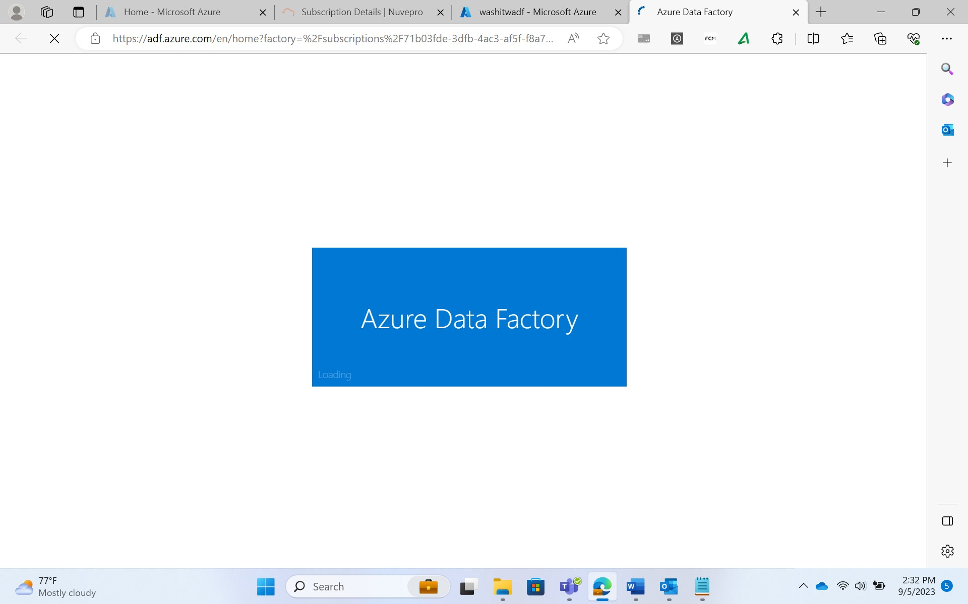

* Creation of Integration Runtime

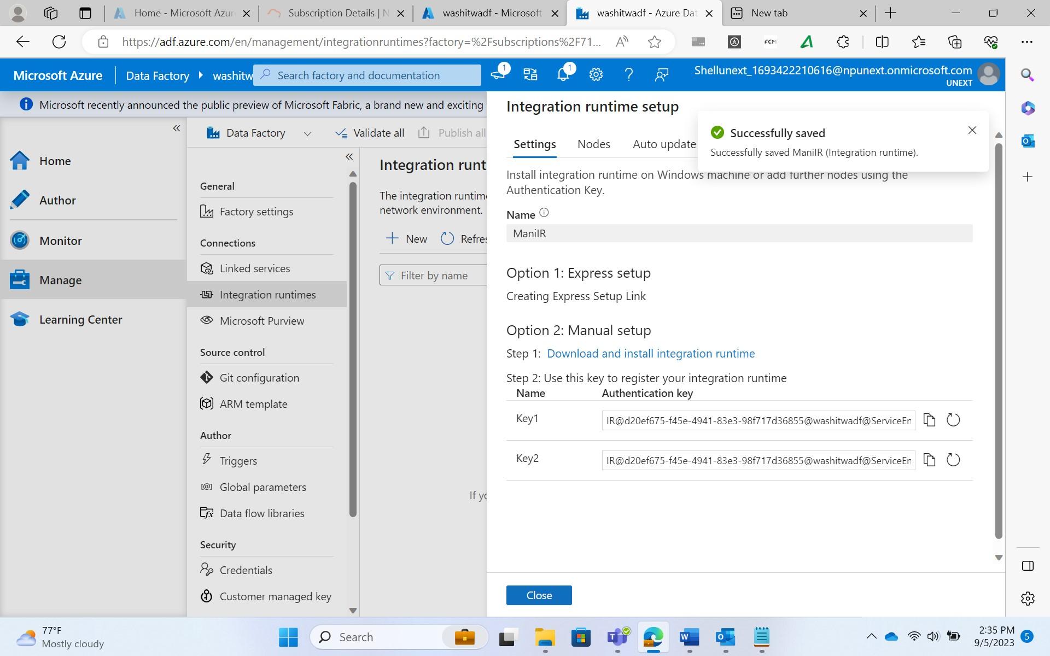

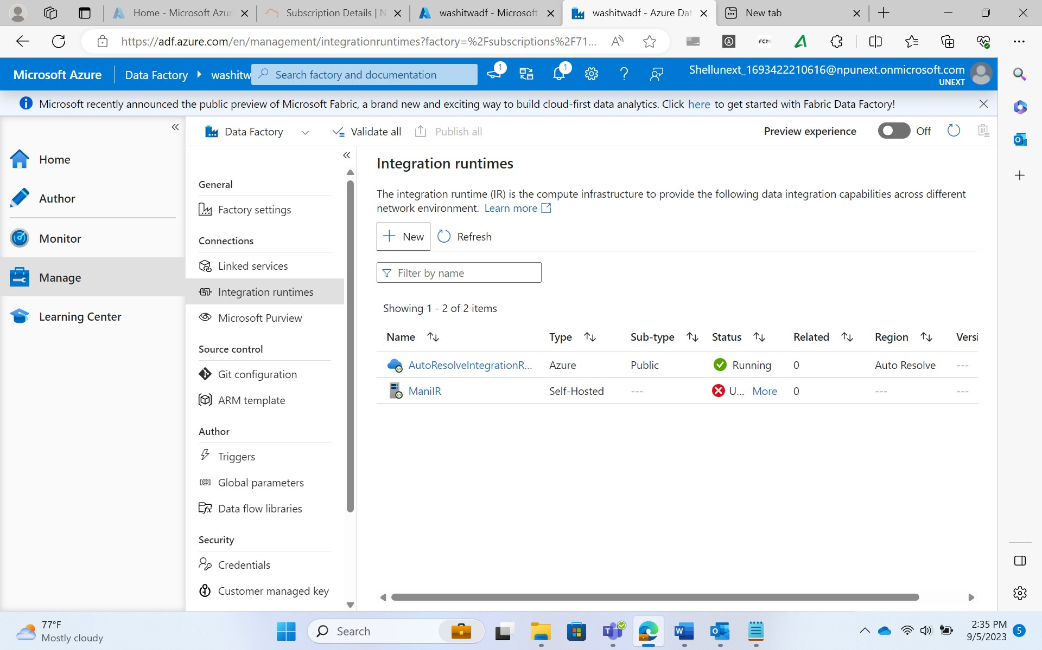

* Creation of linked Service

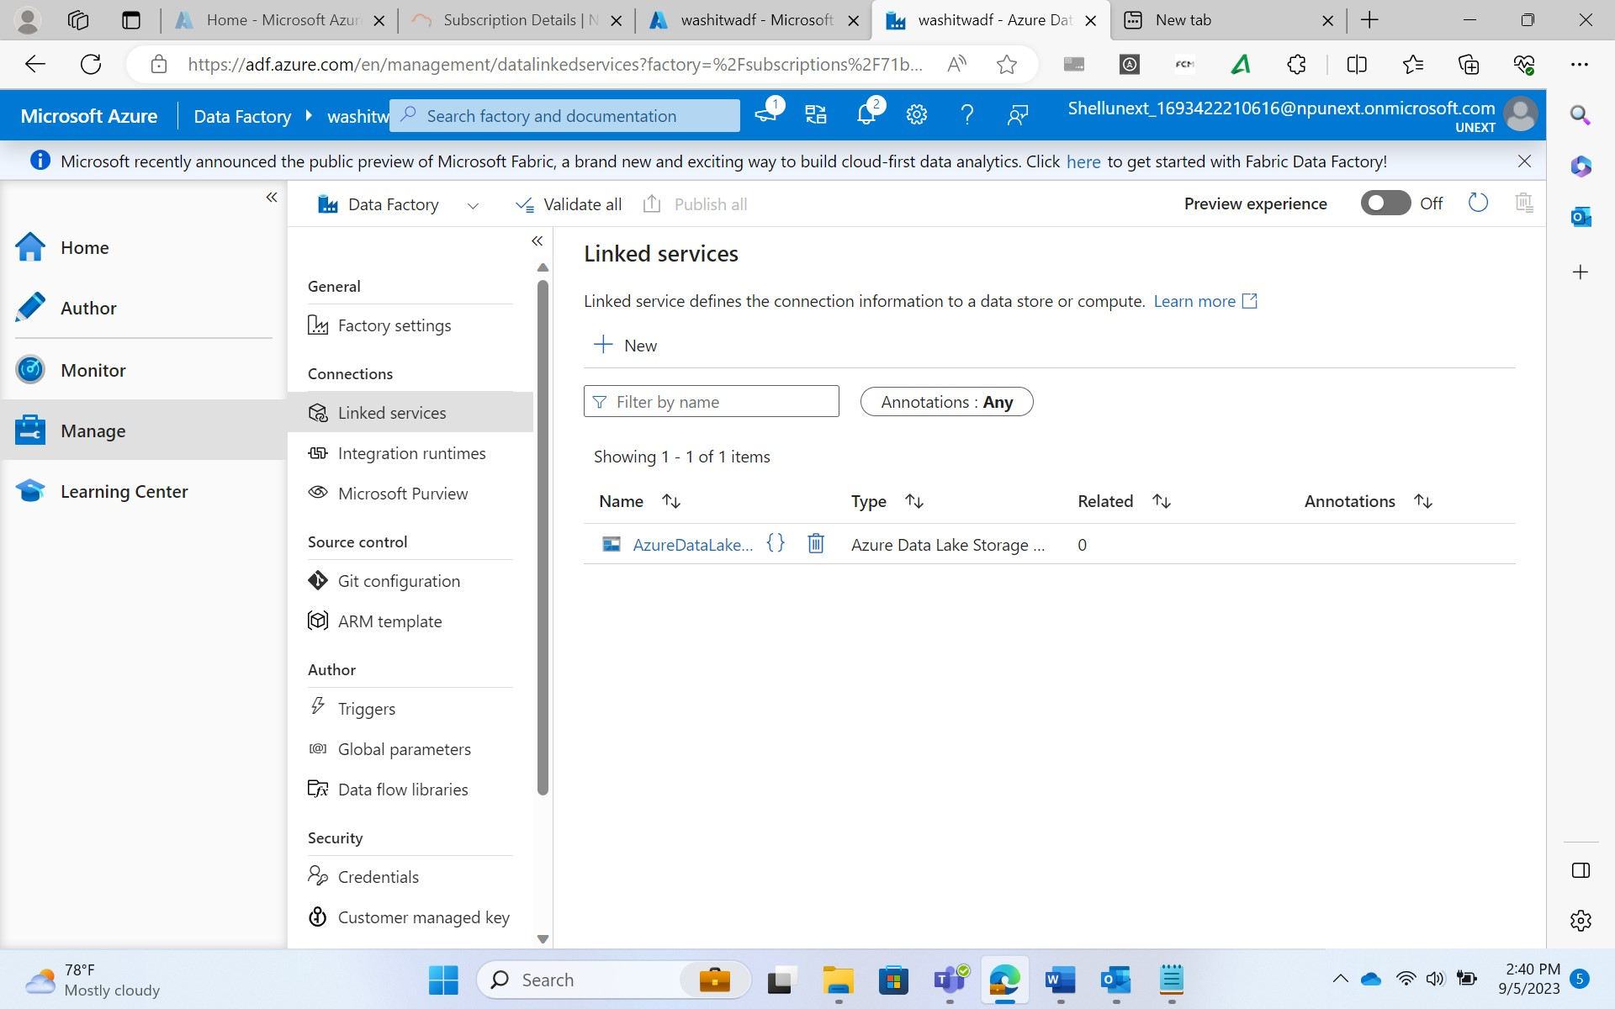

* Creation of Dataset

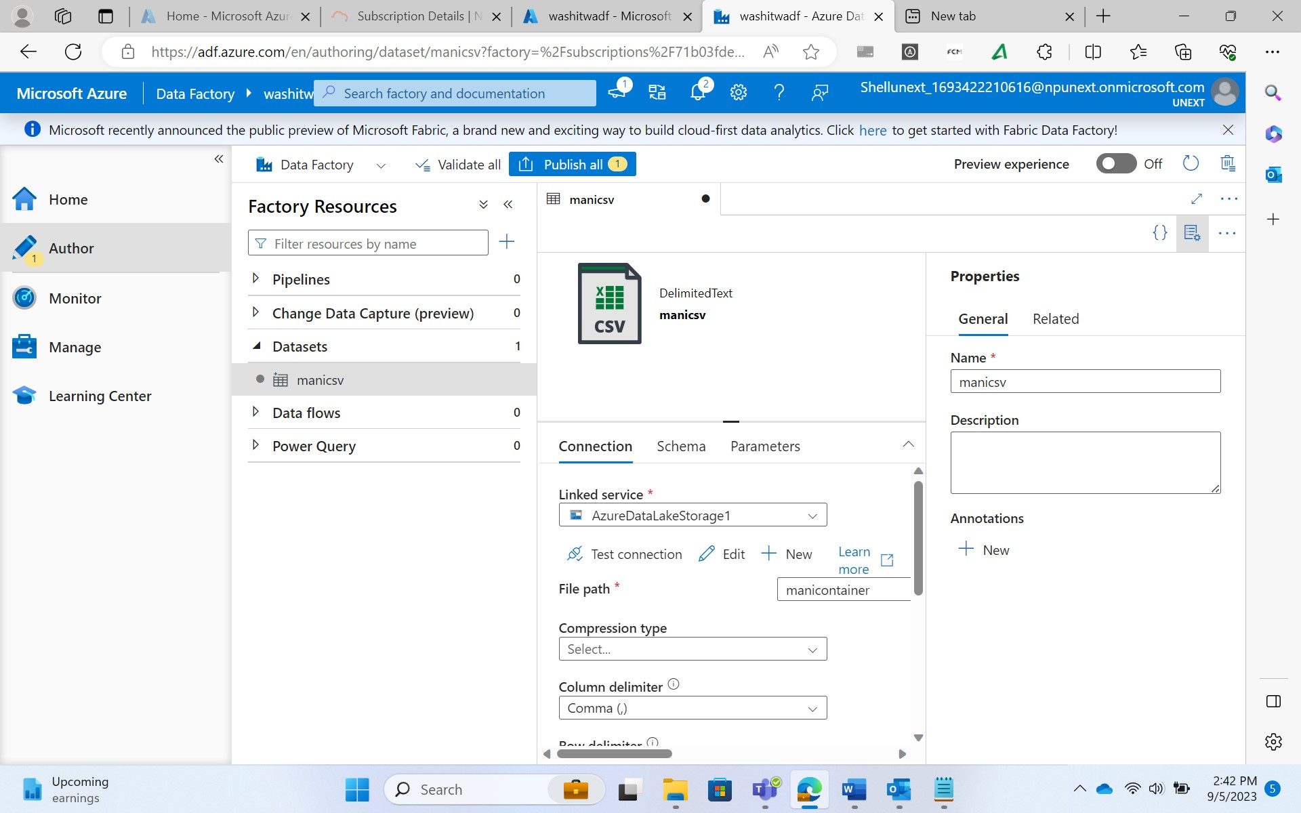

* Creation of Data pipeline

